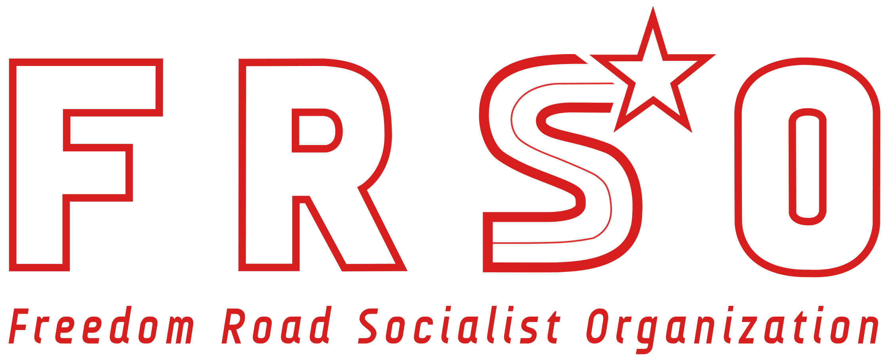 Mick Kelly, Political Secretary P.O. Box 582564

Freedom Road Socialist Organization Minneapolis, MN

+1 612-715-3280 | info@fightbacknews.org 55458-2564 USA

**The contributions of Stalin and the struggle for socialism today**

By Mick Kelly, Political Secretary, Freedom Road Socialist Organization

Dear Comrades,

On behalf of Freedom Road Socialist Organization, I extend our warmest greeting to the participants and organizers of this important event on the teachings of JV Stalin and the struggle of communists today. Conferences such as this one are vital for the international communist movement as they provide a venue for Marxist-Leninists to deepen our understanding of the world and how to change it. We are also glad to hear about the publication of Stalin’s Collected Works in Italy - as everywhere, spreading the thinking and contributions of Stalin help to illuminate the path to revolution and socialism.

The class enemy hates Stalin. When his name comes up, they lie and - just when you think they are going to wrap it up - they lie some more. They do so because Stalin led a vast movement of working class and oppressed peoples that spanned the globe, with the capacity to mount a serious challenge to world capitalism. Like Marx, Engels, Lenin and Mao, he frightened them.

Revolutionaries have one view of things, and those who serve as mouthpieces for monopoly capital have another. How could it be otherwise? Mao made the point that every idea without exception is “stamped with the brand of a class.” This same applies to how one evaluates Stalin. Communists have a positive summation of Stalin’s thinking and practice.

We appreciate the many contributions Stalin made to the theory of Marxism-Leninism. In practice, he was an outstanding proletarian revolutionary who helped lead the revolution in Russia and in the establishment of what would become the USSR. Stalin led the process of socialist construction, transforming a country that had a backward, rural-centered economy into a land that was truly modern in the best sense of the word. The five-year plans developed industry at a pace that was until then unknown. In the vast rural areas, production relations were revolutionized – the old property relations which bore the marks of serfdom were swept away by the movement to collective agriculture. Simultaneously, a revolution was conducted in the societal superstructure and new socialist culture was nurtured.

The USSR was a country encircled by hostile capitalist countries that wanted to destroy it. Stalin proved to be a master at utilizing contradictions in the enemy camp, and when the time came, he provided able leadership to the Great Patriotic War against fascism.

JV Stalin was a great proletarian internationalist who took a keen interest in the workers and national liberation movements around the world. The theory and practice of Stalin, as it can be applied to the situation we find ourselves in today, will be the focus of the rest of this paper.

**Monopoly capitalism and “American Exceptionalism”**

In 1929, the American Commission of the Presidium of the Executive Committee of the Communist International was rocked by a debate that was taking place inside the Communist Party of the USA. Stalin addressed the commission at length, making two major points that are of real importance to communists today. The first was the danger of factionalism and how factionalism undermines the unity that is required by a communist party to act effectively. Stalin spoke of a potential developing revolutionary crisis and stated:

“For that end the American Communist Party must be improved and bolshevized. For that end we must work for the complete liquidation of factionalism and deviations in the Party. For that end we must work for the reestablishment of unity in the Communist Party of America. For that end we must work in order to forge real revolutionary cadres and a real revolutionary leadership of the proletariat, capable of leading the many millions of the American working class toward the revolutionary class struggles. For that end all personal factors and factional considerations must be laid aside and the revolutionary education of the working class of America must be placed above all.”

Stalin went on to state:

“Let us take any factory or plant. Let us assume that the majority of the workers of that factory show an inclination to go on strike, whereas the minority, on the plea of their convictions, declare against a strike. A war of opinions commences, meetings are held, and in the end the vast majority in the factory decide to strike. What would you say of ten or twenty workers, representing a minority in the factory, who declared they would not submit to the decision of the majority of the workers, since they were not in agreement with that decision? What would you call them, dear comrades? You know that such workers are usually called strike-breakers.”

The fact that factionalism is poison to a revolutionary communist organization is well known and must be dealt with accordingly. Less well known was the underlying debate among U.S. communists that was helping to fuel the factional battle – that is the problem of “American exceptionalism.” Long before it became a buzz word in bourgeois political circles and U.S presidential campaigns, in the lead-up to the Great Depression the issue of exceptionalism was a topic of debate among communists.

A group of right opportunists inside the Communist Party, led by J Lovestone, made the argument that the general laws of capitalism - including crisis theory - did not really apply to the U.S., which would be immune from the crisis engulfing the capitalist world. Stalin responded:

“It would be wrong to ignore the specific peculiarities of American capitalism. The Communist Party in its work must take them into account. But it would be still more wrong to base the activities of the Communist Party on these specific features, since the foundation of the activities of every Communist Party, including the American Communist Party, on which it must base itself, must be the general features of capitalism, which are the same for all countries, and not its specific features in any given country.”

The point Stalin is making here is that we must understand the laws of capitalism and that these laws apply in all places you find capitalism.

Today the issue of “American exceptionalism” still comes up. In the U.S. and some other developed capitalist countries, there are those who argue that the laws of change - which are in fact, the laws of society’s development, and which were laid bare by Marx, Lenin, Stalin, Mao and many others - do not apply anymore (if they ever did). So, they say things like the working class is “bought off” and unable to serve its historic role as the grave digger of the capitalist system, ascribing that role instead to social movements. Or take for example the modern revisionists, who remove all that is revolutionary from Marxism. They negate the need for the dictatorship of the proletariat and make the silly argument that it is possible to have a peaceful transition to socialism, or they deny the inevitably of wars being waged by the imperial powers.

**Decline of U.S. imperialism**

Monopoly capitalism is a law-governed system, and revolutionaries can understand those laws. Imperialism is a dying system, and the decline of U.S. imperialism is accelerating. In 1960, the U.S. economy represented about 40% of the world economy. Today, it is about half that. In his work, *Foundations of Leninism*, Stalin states, “Lenin called imperialism ‘moribund capitalism.’ Why? Because imperialism carries the contradictions of capitalism to their last bounds, to the extreme limit, beyond which revolution begins.”

The decline of monopoly capitalism is a real phenomenon that is shaping every social contradiction within the United States. The contradictions within the ruling class are sharpening, and Trump is an ideal political representative of an imperial power in decline.

The fact that Biden/Harris have retained many of Trump’s policies concerning the international financial architecture - including policies that limit the functioning of the World Trade Organization; protectionism; and the “delinking” the economies of the U.S. and People’s China – are indicators that broader economic forces are at work, leading the U.S. ruling class to some points of agreement about what to do in a world where U.S. power is slipping. But on a host of issues, especially those that involve inter-imperialist rivalry such as NATO or the war in Ukraine, there is anything but a consensus.

In U.S. society, the contradictions along class and national lines are also growing sharper. There is a notable uptick in major strikes by U.S. workers, most recently at Boeing by 30,000 members of the International Association of Machinists.

**The National Question**

Among Stalin’s most important theoretical contributions to scientific socialism was his work on the national question. Starting with his pathing-breaking 1913 work *Marxism and the National Question*, Stalin studied and wrote about the movements for national liberation his whole life.

In *Foundations of Leninism* Stalin notes:

“Formerly, the national question was regarded from a reformist point of view, as an independent question having no connection with the general question of the power of capital, of the overthrow of imperialism, of the proletarian revolution. It was tacitly assumed that the victory of the proletariat in Europe was possible without a direct, alliance with the liberation movement in the colonies, that the national-colonial question could be solved on the quiet, "of its own accord," off the highway of the proletarian revolution, without a revolutionary struggle against imperialism. Now we can say that anti-revolutionary point of view has been exposed.”

What is being said here is that those facing national oppression, and the working class of the oppressor nation, face a common enemy, and that movements for national liberation should be actively supported. Under Stalin’s leadership the Soviet Union actively supported the national liberation movements.

Today, the importance of this approach stands out in sharp relief. Palestine is currently the pivot of the revolutionary process in the Middle East, where the heaviest blows are being landed on U.S. and Western imperialism. Likewise, the U.S. itself is a jailhouse of nations. National oppression and systematic inequality are visited upon the African American nation, which has its national territory the Black Belt South, and on the Chicano nation, which has its national territory in the Southwest portion of the U.S.

In the context of imperialism’s rapid decline, the issue of national oppression inside the U.S. is playing an important role in defining the contours of struggle – for example, the 27 million people came out into the streets after the murder of George Floyd. Or the massive demonstrations in support of Palestine over the past year. Understanding the national question has allowed our organization, FRSO, to play an important role in these events.

**Lessons from the past, and looking towards a bright future**

Above all else, Stalin was a revolutionary who never hesitated to point the way forward for the international communist movement, and never hesitated to correct errors when he found them.

For example, in the United States, during the later period of the popular front, especially during World War II, revisionists within the Communist Party went so far as to liquidate the Party. It was the world communist movement, headed by Stalin, that called attention to the problem and demanded the mistakes be addressed.

We are now in a period where large scale radicalization is underway in the U.S. There are more people who view themselves as Marxist-Leninists than at any time since the 1970s. The situation for building a new communist party in the U.S. is excellent.

Marxism-Leninism is a science, and Stalin contributed a lot to our understanding of that science. And we will learn still more by applying it to the concrete conditions we face.

Long live Marxism-Leninism!

Long live the international communist movement!

We have a world to win!